Loops Worksheet AP CSP Name______________
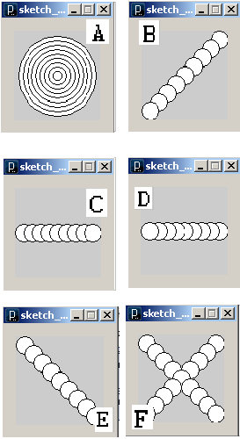
Match each program to the corresponding output.
1.
x = 10
while x < 91:
ellipse(x,50,20,20)
x = x + 10

2.
x = 90
while x > 9:
ellipse(x,50,20,20)
x = x - 10

3.
x = 10
while x < 91:
ellipse(x,x,20,20)
x = x + 10

4.
m = 90
while m > 9:
ellipse(50,50,m,m)
m = m - 10

5.
x = 10
while x < 91:
ellipse(x,x,20,20)

ellipse(100 - x,x,20,20)
x = x + 10

6.
x = 10
while x < 91:
ellipse(100 - x,x,20,20)
x = x + 10
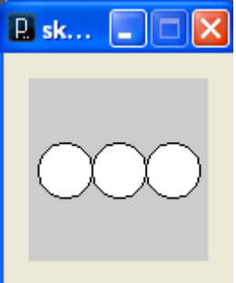
7. Complete the following program so that it produces a pattern of circles similar to that shown

x = ________;

while x < __________:

ellipse(________,_________,30,30)

x = x + ______________

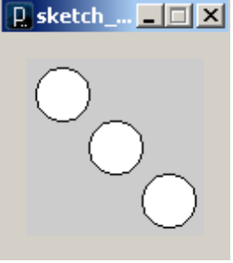
8. Make another program similar to #7, except have the three circles arranged diagonally like this:

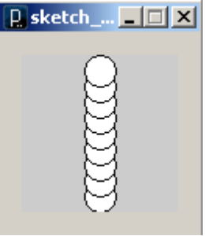
9. Write a program to make a pattern of 9 circles with y coordinates 90, 80, 70, 60, 50, 40, 30, 20, 10. You will have to make the loop “go backwards” so that the circle with a y coordinate of 90 is drawn first.

